Symposium focuses on Vermilion’s health
Zane Hill, Louisiana 9:58 p.m. CDT May 4, 2014
The Daily Advertiser
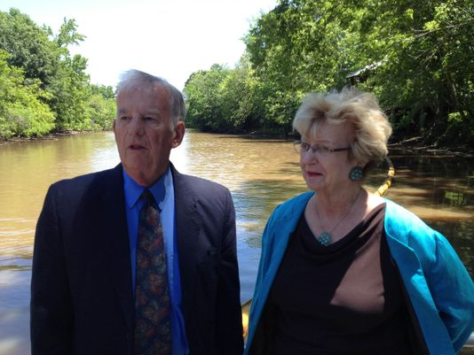
(Photo: Zane Hill )
SHARE 5 CONNECTTWEETCOMMENTEMAILMORE
Charles and Jan Wyatt want Bayou Vermilion District tax money to be spent effectively. The best way to start is to use a trash can, they say.
The two are helping to present the three-day Bayou Vermilion Treasures Water Weekend beginning Thursday at Vermilionville in Lafayette. The event begins with a sunset pontoon boat cruise, a symposium on the effects of pollution on water quality and river maintenance, and ends with a family-oriented day that will include the Horse Farm and Lafayette Science Museum.
The Wyatts said their simple hope is to reach out to people and create awareness, specifically on the mounds of garbage BVD spends its money to clean up. The issue is that people don’t have to be anywhere near the Vermilion River to litter in it.
“Anything that goes into the storm drains in the streets will go directly to the coulees and the river,” Charles Wyatt said.
Last year, cleanup crews removed enough small garbage to fill 1,100 55-gallon drums, and that’s not counting the nearly 500 large objects (stoves, microwaves, refrigerators, TVs and even cars) and approximately 175 tires dragged from the river.
Vermilionville Facilities Maintenance Coordinator Curtis Willingham said cleaning up is “probably 75 percent” of what he, his four-man crew and Lafayette Parish Correctional Center trustees do. They use a series of booms floating around coulee drains to catch most of the floating trash.
Willingham said last week, his employees had to collect trash from a boom underneath a South College Street bridge that hadn’t been handled in a while because the trustees were working on another project.
“We must have pulled 40 55-gallon barrels (of trash) from that location,” he said.
Money to pay for that is generated through a property tax millage in Lafayette Parish, but Jan Wyatt said it would be more effective to use that money for preservation efforts like bank restoration. A lack of plants in some areas is allowing significant bank erosion, which gives the Vermilion River its murkiness.
“Right now, a lot of that money goes to picking up trash,” Jan Wyatt said. “If people stopped throwing their trash in the sewers or coulees, that money could be spent on long-term project.”
The Wyatts’ nonprofit Bayou Vermilion Preservation Association is trying to find ways to do just that and, because it isn’t tied to BVD, can reach out to the Vermilion River’s other parishes and their organizations. Speakers for Friday’s symposium include University of Louisiana at Lafayette professors and local government representatives.
Those interested in the boat cruise, symposium or additional event information should register online at BayouVermilionPreservation.org. Each comes with a $25 registration fee.

